Date | Activity | Place | Time | Price | Last day to book
Thursday 1st July | Word Games | Westbourne Academy | 1:30pm | FREE | Wednesday 30th June
Tuesday 6th July | Kahoot Quiz | Westbourne Academy | 1:30pm | FREE | Tuesday 6th July
Thursday 8th July | Smugglers Cove Mini Golf | Bournemouth Pier | 5.00pm | £10 | Tuesday 6th July
Tuesday 13th July | Conversation Club / Travel | Westbourne Academy | 4:45pm-6:00pm | £6.00 | Tuesday 13th July
Thursday 15th July | Bowling | Branksome – Hollywood bowl | 5.00pm | £7 | Tuesday 13th July
Saturday 17th July | Discover Dorset – Jurassic Coast | Jurassic Coast | 8.30am | £40.00 | Thursday 15th July
Tuesday 20th July | Garden Games | Westbourne Academy | 5:00pm – 6:30pm | FREE | Tuesday 20th July
Thursday 22nd July | Beach Volleyball | Westbourne Academy | 5:00pm – 6:30pm | FREE | Tuesday 20th July
Tuesday 27th July | Table Tennis Tournament | Westbourne Academy | 5:00pm – 6:30pm | FREE | Tuesday 27th July
Thursday 29th July | Laser Quest | Fir Vale Road Bournemouth | 5:00pm – 6:30pm | £8.50 | Tuesday 27th July
Saturday 31st July | Discover Dorset – Jurassic Coast | Jurassic Coast | 8.30am | £40.00 | Thursday 29thJuly
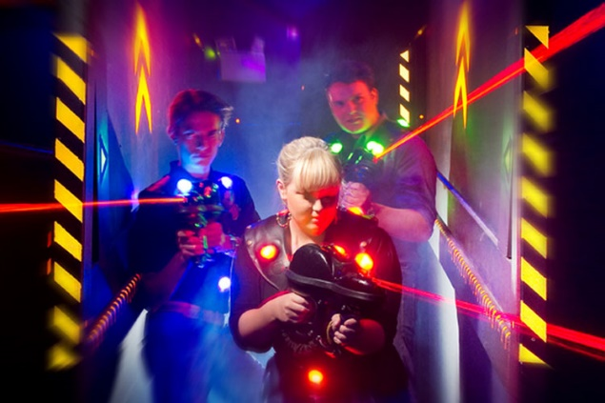
Socials and Excursions July
