2024

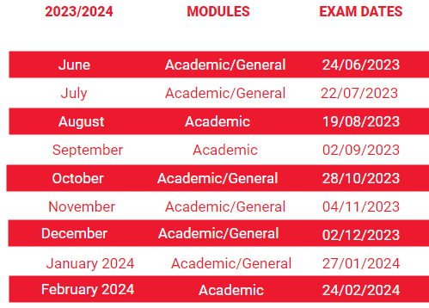
IELTS £225.00

FCE £220.00
Written & Speaking Exam | Closing Date
15th March 2024 | 1st February 2024
15th June 2024 | 1st May 2024
14^{h} December 2024 | 1st November 2024

Written & Speaking Exam | Closing Date
16th March 2024 | 1st February 2024
15th June 2024 | 1st May 2024
14th December 2024 | 1st November 2024
CAE £225.00

